**PROJECT REPORT**

(Project Term June-December 2021)

**Face Recognition and Expression Recognition**

Submitted by

**Abhishek K Singh 11907787**

**Lakkamraju Venkata Sai Manoj Varma 11907874**

**INT 246**

**(B. Tech CSE)**

Under the Guidance of

**Dr. Sagar Pande**

# School of Computer Science and Engineering

**LOVELY PROFESSIONAL UNIVERSITY**

**PHAGWARA, PUNJAB**



**DECLARATION**

We hereby declare that the project work entitled Face Recognition and Expression Recognition is an authentic record of our own work carried out as requirements of Project for the award of B. Tech degree in Computer Science and Engineering from Lovely Professional University, Phagwara, under the guidance of Sagar Pande, during August to November 2021. All the information furnished in this project report is based on our own intensive work and is genuine.

**Name of Student 1:** Abhishek K Singh

**Registration Number:** 11907787

**Name of Student 2:** Lakkamraju Venkata Sai Manoj Varma

**Registration Number:** 11907874

**CERTIFICATE**

This is to certify that the declaration statement made by this group of students is correct to the best of my knowledge and belief. They have completed this Project under my guidance and supervision. The present work is the result of their original investigation, effort, and study. No part of the work has ever been submitted for any other degree at any University. The Project is fit for the submission and partial fulfillment of the conditions for the award of B. Tech degree in Computer Science and Engineering from Lovely Professional University, Phagwara.

**Name of the Mentor:** Dr.Sagar Pande

**School of Computer Science and Engineering,**

Lovely Professional University,

Phagwara, Punjab.

# ACKNOWLEDGEMENT

We take this opportunity to express our deep gratitude and most sincere thanks to our teachers, parents, and friends for giving most valuable suggestion, helpful guidance, and encouragement in the execution of this project work.

We would like to thank our course mentor for guiding us in making the Project work successful.

**TABLE OF CONTENTS**

Title Page……………………………………………………………………………(1)

Declaration…...……………………………………………………………………...(2)

Certificate……..…….……………………………………………………………….(3)

Acknowledgement…………………...…………………………………………........(4)

Table of Contents……………………...…………………………………………….(5)

**1. INTRODUCTION 6**

## 1.1. FACE RECOGNITION SYSTEM 6

## 1.1.1. DATABASES USED 7

## 1.1.2. FRAMEWORK FOR FACE RECOGNITION 7

**1.1.3. APPLICATIONS 7**

**1.1.4. CHALLENGES 7**

**1.1.5. WHY USE THE FACE FOR RECOGNITION? 8**

**1.2. PROBLEM 8**

**1.2.1. GENETIC SEARCHING 9**

**1.2.2. SELECTION 9**

**1.2.3. CROSS-OVER 9**

**1.2.4. MUTATION 10**

**2. SOURCE CODE 12**

**3. CONCLUSION 19**

**4. BIBLIOGRAPHY 20**

**1. INTRODUCTION**

Face recognition is one of the most challenging aspect in the field of image analysis. Face recognition has been a topic of active research since the 1980's, proposing solutions to several practical problems. Face recognition is probably the biometric method that is used to identify people mainly from their faces. However, the recognition process used by the human brain for identifying faces is very challenging. In this paper, a Genetic Algorithm (GA) based approach is proposed for face recognition. The proposed algorithm recognizes an unknown image by comparing it with the known training images stored in the database and gives information regarding the person recognized.

Face recognition is a task of pattern recognition that is specifically performed on faces.In other words, it can be described as classifying a face either known or unknown by comparing a face with stored known individuals in the database. It is also desirable to have a system that has the ability of learning to recognize unknown faces. People have a good ability to recognize and distinguish between faces but recognizing human face automatically by computer is very difficult. The main goal of face recognition technology is to match a given face image against the stored database of images. Face recognition technique uses several other disciplines such as image processing, computer vision, pattern recognition, neural networks and psychology. With the current perceived world security situations, governments as well as businesses require reliable methods to accurately identify individuals, without overly infringing on rights to privacy or requiring significant compliance on the part of the individual being recognized.

**1.1. FACE RECOGNITION SYSTEM**

A face recognition system is developed to demonstrate the application of the proposed method. The system follows the face-based ***approach,*** and it consists of two stages, namely, training and recognition stages. Training stage computes the representational bases for images in the domain of interest (that is reference images) and converts them into training image representations. The training image representations of each image are stored in the library. Using the representational bases recognition stage translates the testing image into probe image representation. Testing image is then matched with reference images which are stored in the library to identify the face image.

**1.1.1.** **DATABASES USED**

We used the FERET database, which has become the standard for evaluating the face recognition technologies, consists of more than 13,000 facial images of more than 1500 subjects. The diversity of the FERET database is related to gender, ethnicity, and age. Images are acquired during different photo sessions hence the illumination conditions, facial expressions and the size of the face have been varied. The dataset used in our experiments consists of 2000 FERET face images corresponding to 250 subjects. The images are of size 256 x 384 with 8-bit resolution. Three sets consisting of galleries and probes were used for evaluating the performances of the algorithms. The training set is the set of known facial images, which are used for training. The images in the probe set are the unknown facial images to be recognized.

### **1.1.2. FRAMEWORK FOR FACE RECOGNITION**

### Face recognition is a technique that takes the image of a person (query image) and compares it with the previously recorded images in the database. This is done by comparing the invariant features obtained from the techniques that capture the representative variability of the faces or the structure, the shape, and the face attributes like distance between the eye centers and nose, upper outlines of the eyes, width of eyebrows, etc. Face recognition has the benefit of being a passive, non-intrusive system to verify personal identity in a natural and friendly way. The main benefit of this technique over other biometric approaches is that the face images can be taken from a distance even without the knowledge of the individual being observed as might be required in identifying the presence of the criminals in a bank or government offices, etc.

### **1.1.3. APPLICATIONS**

It has become one of the most active research areas especially in recent years as it has a variety of wide applications in the areas:

* Public security
* Law enforcement and commerce
* Credit card verification
* Criminal identification
* Access control
* Human-computer intelligent interaction
* Digital libraries and information security

**1.1.4. CHALLENGES**

The challenges associated with face recognition can be attributed to the following factors:

* Presence or absence of structural components: Facial features such as beards, mustaches, and glasses may or may not be present and there is a great deal of variability among these components including shape, color, and size.
* Pose: The images of a face vary due to the relative camera-face pose (frontal, tilted, profile, upside down).
* Facial expression and emotions: The appearance of faces is directly affected by a person’s facial expression and emotions.
* Occlusion: Faces may be partially occluded by other objects. For an example, in an image with a group of people, some faces may partially occlude other faces (face identification).
* Image orientation: Face images directly vary for different rotations about the camera’s optical axis.
* Imaging conditions: When the image is formed, factors such as lightning and camera characteristics affect the appearance of a face.
* Age: Images taken after one- or two-year’s gap may not match with the images in database.

**1.1.5. WHY USE THE FACE FOR RECOGNITION?**

Biometric-based techniques have emerged as the most promising option for recognizing individuals in recent years, instead of authenticating people and granting them access to physical and virtual domains based on passwords, PINs, smart cards, plastic cards, tokens, keys and so forth, these methods examine an individual’s physiological and/or behavioral characteristics to determine and/or ascertain his identity. Passwords and PINs are hard to remember and can be stolen or guessed; cards, tokens, keys, and the like can be misplaced, forgotten, purloined, or duplicated; magnetic cards can become corrupted and unreadable. However, an individual’s biological traits cannot be misplaced, forgotten, stolen, or forged. Biometric-based technologies include identification based on physiological characteristics (such as face, fingerprints, finger geometry, hand geometry, hand veins, palm, iris, retina, ear, and voice) and behavioral traits (such as gait, signature, and keystroke dynamics).

**1.2. PROBLEM**

The recognition of faces through face recognition technique relies on detecting the individuals features such as the eyes, nose, mouth, and head outline, and defining a face model by the position, size, and relationships among these features. Such approaches to face recognition are di cult to extend to multiple views and often been quite fragile, requiring a good initial guess to guide them. Research related to human strategies in the field of face recognition has shown that individual features and their immediate relationships comprise an insufficient representation to account for the performance of adult human face identification.

**1.2.1. GENETIC SEARCHING**

The Genetic Algorithm (GA) is a stochastic search method based on the mechanics of natural selection and genetics analogous to natural evolution. Central to the idea of GA is a population of individuals, each representing a possible solution to the given problem. Each, known as chromosome (usually represented by a bit string consisting of 0s and 1s), is assigned to a fitness value based on how good their solution to the problem is. The individuals then evolve through successive iterations called generations. During one generation, highly fit individuals are given the opportunity to mate with other individuals in the population. Since the least fit individual in the population are less likely to get selected for mating, they disappear from future generations. As a result, the population of individuals converges to an optimal solution to the problem. GAs are robust and can deal successfully with a wide range of problem areas, including those which are difficult for other methods to solve.

To apply GA for face detection, a template of the face image obtained from averaging the gradation level of pixels of several similar looking face images of several persons is constructed. The template face image is then moved through the whole image to find the location where the most suitable match exists. This process applies GA for the optimization of five parameters such as, center position of the template image, scaling of the template, rotation of the template and matching rate between the input image and the template image.

**1.2.2. SELECTION**

Selection operator is a process in which chromosomes are selected into a mating pool according to their fitness function. Good chromosomes that contribute their gene-inherited knowledge to breed for the next generation are chosen. Here we use conventional elitist selection scheme to select an elitist chromosome with the highest fitness value, which is copied directly into the new population of next generation. The other chromosomes are selected by a roulette-wheel selection process, where the selection probability of each individual is proportional to its fitness value.

**1.2.3. CROSS-OVER**

This operator randomly chooses a crossover point where two parent chromosomes break and then exchanges the chromosome parts after that point. As a result, two offspring are generated by combining the partial features of two chromosomes. If a pair of chromosomes does not cross over, then the chromosome cloning takes place, and the offspring are created as exact copies of each parent. Here we have studied single point cross-over, two-point cross-over and uniform cross-over operators. The cutting points are selected randomly within the chromosome for exchanging the contents.

**1.2.4. MUTATION**

Mutation, which is rare in nature, represents a change in the gene and aids us in avoiding loss of genetic diversity. Its role is to provide a guarantee that the search algorithm is not trapped on a local optimum.

This operator alters a randomly selected gene of chromosome with a very low probability, PM. For each chromosome, generate a random value between [0,1]. If the random value is less than PM, then choose a bit at a random location to flip its value from 0 to 1, or 1 to 0.

The fundamental steps employed for the genetic algorithm are as follows:

**Step 1:** Initialization: Generate randomly a population of chromosomes of size N: x1, x2,.....,xN. Assign the crossover probability Pc and the mutation probability PM.

**Step 2:** Evaluation: Evaluate the fitness function to measure the performance or fitness for individual chromosome in the population. The fitness function establishes the basis for selecting chromosomes that will be mated during reproduction.

**Step 3:** Selection: Select a pair of chromosomes for mating. Use the roulette wheel selection procedure, where each chromosome is given a slice of a circular roulette wheel. The area of the slice within the wheel is equal to the chromosome fitness ratio. Obviously, the highly fit chromosomes occupy the largest areas, where the chromosomes with least fit have much smaller segments in the wheel. To select a chromosome for mating, a random number is generated in the interval [0,100] and the chromosome whose segment spans the random number is selected.

**Step 4:** Cross-over: Produce two off-springs from two parent chromosomes. With the cross-over probability Pc, exchange parts of the two selected chromosomes and create two offspring.

**Step 5:** Mutation: Apply the conventional mutation operation to the population with a mutation rate PM. With this mutation probability, randomly change the gene values in the two offspring chromosomes.

**Step 6:** Termination test: If a predefined termination condition is satisfied, go to Step 7, else go to Step 2.

**Step 7:** Preservation: Keep the best chromosome.

Step 8: End.

On processing the genetic operation, the face area is detected on the image. The exact locations of the facial features are then searched. Six facial features are localized in this experiment. These are the left and right pairs of eyes, eyebrows, tip of the nose and the center of the mouth. Facial features are extracted from the face profile depending on their geometrical arrangement on the facial skeleton.

**SOURCE CODE**

import numpy as np

import pandas as pd

import os

import tensorflow as tf

from keras.preprocessing.image import ImageDataGenerator, load_img

from keras.layers import Conv2D, Dense, BatchNormalization, Activation, Dropout, MaxPooling2D, Flatten

from keras import regularizers

from keras.callbacks import ModelCheckpoint, CSVLogger, TensorBoard, EarlyStopping, ReduceLROnPlateau

import datetime

import matplotlib.pyplot as plt

train_dir = 'Downloads/fer2013/train/'

test_dir = 'Downloads/fer2013/test/'

row, col = 48, 48

classes = 7

def count_exp(path, set_):

dict_ = {}

for expression in os.listdir(path):

dir_ = path + expression

dict_[expression] = len(os.listdir(dir_))

df = pd.DataFrame(dict_, index=[set_])

return df

train_count = count_exp(train_dir, 'train')

test_count = count_exp(test_dir, 'test')

print(train_count)

print(test_count)

train_count.transpose().plot(kind = 'bar')

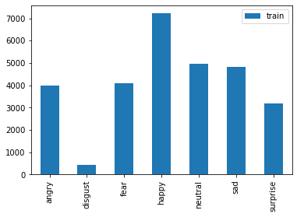

test_count.transpose().plot(kind = 'bar')

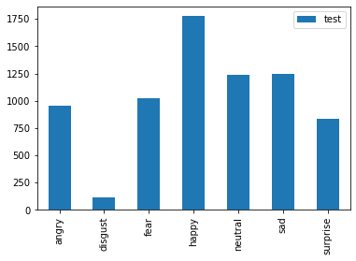

plt.figure(figsize = (14,22))

i = 1

for expression in os.listdir(train_dir):

img = load_img((train_dir + expression +'/'+ os.listdir(train_dir + expression)[1]))

plt.subplot(1, 7, i)

plt.imshow(img)

plt.title(expression)

plt.axis('off')

i += 1

plt.show()

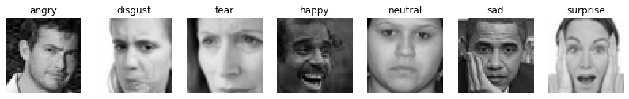

train_datagen = tf.keras.preprocessing.image.ImageDataGenerator(rescale = 1./255,

zoom_range = 0.3,

horizontal_flip = True)

training_set = train_datagen.flow_from_directory(train_dir,

batch_size = 64,

target_size = (48, 48),

shuffle = True,

color_mode = 'grayscale',

class_mode = 'categorical')

test_datagen = tf.keras.preprocessing.image.ImageDataGenerator(rescale = 1./255)

test_set = test_datagen.flow_from_directory(test_dir,

batch_size = 64,

target_size = (48, 48),

shuffle = True,

color_mode = 'grayscale',

class_mode = 'categorical')

training_set.class_indices

def get_model(input_size, classes = 7):

#Initialising the CNN

model = tf.keras.models.Sequential()

model.add(Conv2D(32, kernel_size = (3, 3), padding = 'same', activation = 'relu', input_shape = input_size))

model.add(Conv2D(64, kernel_size = (3, 3), activation = 'relu', padding = 'same'))

model.add(BatchNormalization())

model.add(MaxPooling2D(pool_size = (2, 2)))

model.add(Dropout(0.25))

model.add(Conv2D(128, kernel_size = (3, 3), activation = 'relu', padding = 'same', kernel_regularizer = regularizers.l2(0.01)))

model.add(Conv2D(256, kernel_size = (3, 3), activation = 'relu', kernel_regularizer = regularizers.l2(0.01)))

model.add(BatchNormalization())

model.add(MaxPooling2D(pool_size = (2, 2)))

model.add(Dropout(0.25))

model.add(Flatten())

model.add(Dense(1024, activation = 'relu'))

model.add(Dropout(0.5))

model.add(Dense(classes, activation = 'softmax'))

#Compliling the model

model.compile(optimizer = tf.keras.optimizers.Adam(learning_rate = 0.0001, decay = 1e - 6),

loss = 'categorical_crossentropy',

metrics = ['accuracy'])

return model

fernet = get_model((row, col, 1), classes)

fernet.summary()

tf.keras.utils.plot_model(fernet, to_file = 'fernet.png', show_shapes = True, show_layer_names = True)

chk_path = 'ferNet.h5'

log_dir = "checkpoint/logs/" + datetime.datetime.now().strftime("%Y%m%d-%H%M%S")

checkpoint = ModelCheckpoint(filepath = chk_path,

save_best_only = True,

verbose = 1,

mode = 'min',

moniter = 'val_loss')

earlystop = EarlyStopping(monitor = 'val_loss',

min_delta = 0,

patience = 3,

verbose = 1,

restore_best_weights = True)

reduce_lr = ReduceLROnPlateau(monitor = 'val_loss',

factor = 0.2,

patience = 6,

verbose = 1,

min_delta = 0.0001)

tensorboard_callback = tf.keras.callbacks.TensorBoard(log_dir = log_dir, histogram_freq = 1)

csv_logger = CSVLogger('training.log')

callbacks = [checkpoint, reduce_lr, csv_logger]

steps_per_epoch = training_set.n // training_set.batch_size

validation_steps = test_set.n // test_set.batch_size

hist = fernet.fit(x = training_set,

validation_data = test_set,

epochs = 60,

callbacks = callbacks,

steps_per_epoch = steps_per_epoch,

validation_steps = validation_steps)

plt.figure(figsize = (14, 5))

plt.subplot(1, 2, 2)

plt.plot(hist.history['accuracy'])

plt.plot(hist.history['val_accuracy'])

plt.title('Model Accuracy')

plt.xlabel('Epochs')

plt.ylabel('Accuracy')

plt.legend(['train', 'test'], loc = 'upper left')

plt.subplot(1, 2, 1)

plt.plot(hist.history['loss'])

plt.plot(hist.history['val_loss'])

plt.title('model Loss')

plt.xlabel('Epochs')

plt.ylabel('Loss')

plt.legend(['train', 'test'], loc = 'upper left')

plt.show()

train_loss, train_accu = fernet.evaluate(training_set)

test_loss, test_accu = fernet.evaluate(test_set)

print("Final train accuracy = {:.2f} , validation accuracy = {:.2f}".format(train_accu * 100, test_accu * 100))

y_pred = fernet.predict(training_set)

y_pred = np.argmax(y_pred, axis = 1)

class_labels = training_set.class_indices

class_labels = {v:k for k,v in class_labels.items()}

from sklearn.metrics import classification_report, confusion_matrix

cm_train = confusion_matrix(training_set.classes, y_pred)

print('Confusion Matrix')

print(cm_train)

print('Classification Report')

target_names = list(class_labels.values())

print(classification_report(training_set.classes, y_pred, target_names = target_names))

plt.figure(figsize = (8, 8))

plt.imshow(cm_train, interpolation = 'nearest')

plt.colorbar()

tick_mark = np.arange(len(target_names))

_ = plt.xticks(tick_mark, target_names, rotation = 90)

_ = plt.yticks(tick_mark, target_names)

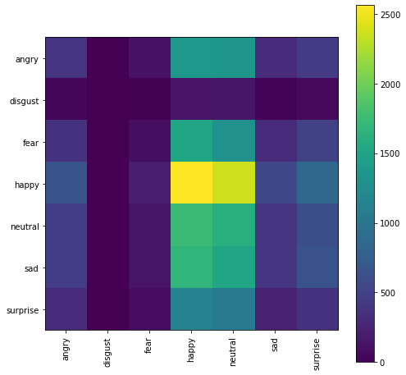

y_pred = fernet.predict(test_set)

y_pred = np.argmax(y_pred, axis = 1)

class_labels = test_set.class_indices

class_labels = {v:k for k,v in class_labels.items()}

cm_test = confusion_matrix(test_set.classes, y_pred)

print('Confusion Matrix')

print(cm_test)

print('Classification Report')

target_names = list(class_labels.values())

print(classification_report(test_set.classes, y_pred, target_names = target_names))

plt.figure(figsize = (8, 8))

plt.imshow(cm_test, interpolation = 'nearest')

plt.colorbar()

tick_mark = np.arange(len(target_names))

_ = plt.xticks(tick_mark, target_names, rotation = 90)

_ = plt.yticks(tick_mark, target_names)

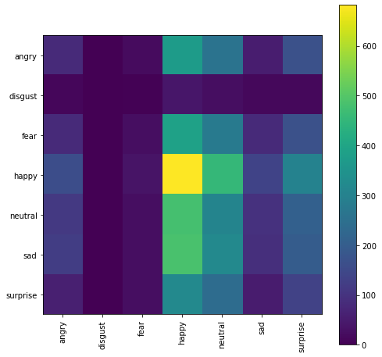

**CONCLUSION**

Detection of human faces is a problem that appears time. This task, which seems effortless for humans, does not lend itself easily to computational approaches. Though human beings accomplish these tasks countless times a day, they are still very challenging for machine vision. Most of the researchers attack this kind of problem with face localization and feature selection with frontal view faces and without facial expression and normal lighting conditions although the variation between the images of the same face is too large due to facial expression, hair style, pose variation, lighting conditions, make-up, etc. In this study, face detection has been implemented using genetic algorithm to search for the face of a particular individual in an image. The effectiveness of the face detection algorithm has been tested both in simple and complex backgrounds for different types of face and non-face images of 320x240 resolution. The algorithm can detect the faces in the images with different backgrounds and lighting conditions. Our next approach is to extend the algorithm for multi-face detection and overlapping faces in images and to detect facial poses and develop a gaze estimation algorithm that will be able to detect an eye in a face image and estimate the gaze direction. Our main target is to instruct operations to robots and make them understand the human’s intentions and interests over facial expressions so that they would be capable of grasping with more intelligence while working cooperatively with human beings.

# BIBLIOGRAPHY

1. <https://www.researchgate.net/>
2. <https://www.kaggle.com>